CHEMICAL ENGINEERING TRANSACTIONS  VOL. , 2023 | A publication of
The Italian Association
of Chemical Engineering
Online at www.cetjournal.it

Guest Editors: Paolo Ciambelli, Luca Di Palma
Copyright © 2023, AIDIC Servizi S.r.l.
ISBN 979-12-81206-00-7; ISSN 2283-9216

Graphene Oxide (GO) and its Ability to Detect and Capture Bacteria and Viruses
Petra Roupcova^{a*}, Karel Klouda^{a,b}, Sabina Kleinovaª
ª VSB - Technical University of Ostrava, Ostrava, Czech Republic
^{b} Occupational Safety Research Institute, Prague, Czech Republic
*petra.roupcova@vsb.cz

Abstract
In recent years, the development of research into nanomaterials has increased the number of their various applications in almost all possible areas, from electrodes to membranes to sports equipment and clothing. Graphene, graphene oxide (GO) and reduced graphene oxide (rGO) are becoming more and more popular mainly due to their extraordinary properties and structure. This contribution summarises the possible use of graphene oxide to capture bacteria and viruses and other potential applications, especially with regard to the ongoing coronavirus crisis.
  - Introduction
Graphite is a naturally layered compound with sp 2 hybridisation with a layer-to-layer distance of 3.38 Å (Roupcova, 2018). The planar layer of graphite consists of six-membered C-cycles (honeycombs), from this natural compound, a number of compounds with a carbon skeleton can be prepared, among other things. Graphite can be intercalated, fluorinated, oxidised and ultimately exfoliated (Roupcova, 2018). The oxidation of graphite with strong oxidising agents prepares GO, which is a precursor for the chemical preparation of graphene (Zhang et al., 2011). GO is a compound that contains major functional groups on the carbon skeleton, such as carboxyl, carbonyl, epoxy and ether groups and hydroxy groups. The utilisation of its functional groups can be realised by its functionalisation by chemical means, such as amidation, esterification and substitution (Roupcova, 2018). GO has unique properties: electronic, magnetic, optical, thermal (Chung et al., 2013; Xu et al., 2013); it is an electrical insulator, hygroscopic and dispersible (Arthi et al., 2015). By choosing the processing technology, its different modifications can obtain, in suspension, quantum dot (Hermanova et al., 2016; Hermanova et al., 2015; Kasbe et al., 2021) films, which find applications in biology, electrical engineering, optics (Chang et al., 2013) and biomedicine (Fernandez- Merino et al., 2010; Sachez et al., 2012). Some of the recent studies are devoted to its antimicrobial properties. The antimicrobial activity of GO has been experimentally demonstrated on a number of Gram-negative bacteria (Klebsiella pneumoniae, Proteus mirabilis, Pseudomonas aeruginosa), Gram-positive bacteria (Staphylococcus aureus, Streptococcus mutans) and also on fungi (Fusarium graminearum, Fusarium oxysporum) (Ghulam et al., 2022; Chen et al., 2014). Both physical and chemical factors are involved in the antimicrobial activity. Physical factors may include mechanical damage to the bacterial membrane by the "sharp" edges of the nanosheets and penetration into the bacterial cell leading to leakage of the intracellular matrix. This damage can result in the death of the bacterial cell. The chemical factor is oxidative stress, which could be caused by the presence of reactive oxygen species (ROS), and could also be ROS-independent (Mangadlao et al., 2015). The effect on microorganisms is also influenced by the size and morphology of GO, degree of oxidation, purity, aggregation, or composite with another nanoparticle (Omran and Baek, 2022).
  - Virus interaction with GO
The virus spreads by binding to host cell surface receptors. GO can be used to capture the virus and prevent infection. Due to its negative charge, it resembles the linear polysaccharide heparan sulphate (HS) to which the virus normally binds. In 2014, an experiment was performed with the herpes simplex virus (HSV-1) and GO in Vero cell culture (Sametband et al., 2014). GO acted as a competitive inhibitor and prevented the virus from binding to the HS. The efficacy of GO was also compared with partially reduced sulfonated GO. The zeta potentials of both compounds were found to be similar negative values and thus the binding of sulfonic groups did not significantly alter the functionality of the inhibitor.
The influence of the charge and structure of the inhibitor on its antiviral activity was confirmed by a 2015 study (Ye et al., 2015). The experiment was performed with the porcine epidemic diarrhoea virus (PEDV, RNA virus) and pseudorabies virus (PRV, DNA virus), two viruses isolated from infected pigs. The inhibitors tested were graphite, graphite oxide, GO, reduced graphene oxide (rGO), and composites of GO with PDDA or PVP. Both GO and rGO were confirmed to have the ability to prevent both RNA and DNA binding of the virus to the host cell, which corresponded with their similar negative zeta potential. Thus, GO and rGO can be used as inhibitors as long as their negative charge is maintained. No antiviral activity was detected for graphite, whereas graphite oxide showed much less activity than GO. Thus, the single-layer structure of GO and rGO also contributes to their ability to inhibit virus spread, and even these substances are able to disrupt the virus envelope and weaken its functionality. However, inhibition does not occur if the virus comes into contact with the host cell before the inhibitor.
There are many different viruses with different structures. HSV-1, PEDV and PRV, mentioned above, have an extra lipid membrane compared to other viruses. Whether the presence of this envelope affects the antiviral properties of GO was investigated by a Taiwanese research team in 2016, when they compared the effects on feline coronavirus (FCoV, feline, enveloped virus) and infectious bursitis in poultry (IBD, unenveloped virus). GO was only able to capture the enveloped virus. A composite of GO and silver nanoparticles, which were dispersed uniformly over the surface of GO, was prepared to contain the enveloped virus, thus preventing the aggregation of the nanoparticles. The authors of this paper hypothesize that the electrostatic interactions between the virus and GO and the binding between the silver nanoparticles and the sulphonyl groups of the virus proteins contribute to the capture of the envelopeless virus (Chen et al., 2016).
    - Types of sensors for virus particle detection
For virus detection using biosensors, it is important that the sensors have high sensitivity and are selective for the virus type. The ideal choice is GO, which, due to its large surface area, can capture a larger amount of detected substances. In addition, different functional groups can be attached to it, increasing the selectivity of the sensor.
According to the physical phenomena and the measurable quantities of the materials used to prepare the sensor, sensors are divided into optical, electrochemical, piezoelectric, magnetic, thermal and others.
Optical sensors can operate, for example, on the principle of measuring fluorescence. In order to observe it, a fluorescent reagent needs to be added to the substance under investigation. In 2017, GO was used as the basis of an optical sensor to determine the infectivity of the influenza virus, since the mutation of one strain of the virus can potentially cause infectivity for humans (Song et al., 2017). For whom a given influenza strain is infectious was determined using two different fluorophores that were bound to the host cells of a bird or human. Thus, the sensor consisted of human and avian receptors labelled with a fluorophore bound to a GO layer used to quench the fluorescence. Depending on the specificity of the viral hemagglutinin receptor, the virus binds to glycan receptors in the bird, human or both. The light emission of one, two or both wavelengths can then be observed in the fluorescence spectrum depending on the fluorophore present in the host cell. Since the H7N9 influenza virus under investigation bound both glycan receptors, two different peaks were measured in the fluorescence spectrum. This virus strain thus has dual specific receptors and is infectious to both birds and humans. This method allows rapid determination of the specificity of a given virus strain for both species simultaneously.
To make electron transfer more efficient and increase the sensitivity of the measurement, the Chinese research group decided to supercharge GO with nitrogen and sulphur and reduce it (Chen et al., 2016a). During the solvothermal synthesis, 2-aminothiophenol was added to the aqueous GO solution as a source of both dopants. The dry product was then thermally reduced (abbreviated as N,S-rGO). Not only the whole viral unit, but also its nucleic acid could be detected. So-called DNA probes are used for their detection. In this case, the hepatitis B virus and the HIV virus chain were each labelled differently with large quantum dots of cadmium selenide. In the blank sample (a DNA probe with N,S-rGO), the fluorescence was rapidly quenched. After the addition of the DNA of the virus under study, the intensity of the absorbed radiation increased again.
GO can also be used as a component of electrochemical sensors. In 2017, a membrane for the detection of the HIV-1 virus was developed (Nehra et al., 2017). The GO solution was vacuum filtered through a polycarbonate membrane. To trap the virus, the polymer EDC-NHS was attached to the GO and anti-HIV antibodies were attached to it. Due to the laminar arrangement of the several trapped GO layers, only very small particles can pass through the channels between the layers, changing the values of the measured current flowing between the two electrodes. In the case of virus capture by antibodies, the value of the measured current decreases, confirming the presence of the virus.
Miniaturised sensors that can be worn on textiles would also be useful in the field. We could be informed of the presence of the virus in an instant and prevent large numbers of people from being infected. They would be of greater importance, especially to health professionals. In 2018, American researchers produced a wearable sensor based on textiles or polyamide. (Kinnamon et al., 2018). A silver layer was screen-printed onto them to create two electrodes, which were used to collect data to assess stability using electrochemical impedance spectroscopy (EIS). The coating on textiles showed higher stability compared to the use of polyamide. The silver electrodes were complemented by a GO layer to which a succinimide derivative was bonded as a linker for the influenza virus antibody. The binding of the virus receptor to the antibody resulted in a change in impedance. The presence of GO enhances the electrochemical properties of the sensor and, due to the low detection limit, it would be possible to determine whether a person is infected before the first symptoms appear.
Lateral flow tests (LFTs) work on the principle of the colorimetric determination of the presence of the virus in the organism. They are combined with amplification methods to amplify the genetic information in the sample to speed up the determination. In 2017, the combination of LFTs with the most common amplification method i.e., a polymerase chain reaction (PCR), was tested (Li et al., 2017). The antigen test on which the biological sample was applied contained three GO-coated membranes instead of one conventional glass fibre membrane. These maximised the uptake of primers and their dimers from the coated sample of PCR products. This increased the sensitivity of the assay compared to the assay without GO membranes, as primer dimers can bind to antibodies on the test line and the sample can then be a false positive. With more membranes, although a higher percentage of primers were captured, there was washout with the GO buffer.
A three-dimensional GO sponge was prepared for the capture of the rotavirus, which is found in polluted water and is very dangerous, especially for children (Fan et al., 2014). GO layers were modified with thionyl chloride to which core(Fe)-shell(Au) nanoparticles were anchored through the amino group of cysteamine. The crosslinking into a 3D structure was achieved by linking the amino groups to the hydroxyl groups of polyethylene glycol (PEG). Subsequently, rotavirus antibodies were bound to both GO and nanoparticles. After immersion in rotavirus-containing water, more than 99% of the virus was absorbed by the fungus. The virus could also diffuse inside the sponge due to its high porosity (pore size in the micrometer range). The specific surface area (BET) was calculated to be 420 m² g⁻¹. Moreover, the fungus was very easy to separate using a magnet due to the magnetic properties of the nanoparticles. In addition to the virus itself and its genetic information, the presence of substances produced by the infected organism (proteins, antibodies, enzymes) can be used to determine the presence of the virus.
    - GO and SARS-CoV-2
The outbreak of a coronavirus pandemic in 2019 has forced scientists around the world to quickly start looking for ways to detect and defend against this infection in the body. This has made GO research even more popular given the medical applications published so far. However, there is a need to work with the smallest possible particles, as the average size of SARS-CoV-2 virus particles is around 100 nm. In the case of droplets, their size can be as small as half that.
In 2021, GO was tested for its antiviral effects against three different coronaviruses, BCoV (bovine coronavirus), PEDV and SARS-CoV-2 (Chung et al., 2021). Each virus was added to a solution of GO (particles smaller than 50 nm) in a culture medium along with 5% FBS (foetal bovine serum) and samples were incubated at body temperature for one hour. Subsequently, the samples were plated on Vero cells. The highest inhibition efficiency of BCoV (72%) and PEDV (62%) was achieved for samples containing GO, which was diluted 1:50. At higher dilutions (up to 1:800), the presence of GO had almost no effect. For SARS-CoV-2, no efficacy was determined, but only samples diluted at a maximum of 1:8 and no higher did not replicate the virus. The effect of GO concentration in the test media should be further studied. The inactivation of Sars-CoV-2 coronavirus by GO application is described. The antiviral effect was tested on 3 strains of SARS-CoV-2:WUHAN, B 1.1.7 (KK-variant A P.1 (Brazilian variant) with up to 98% efficacy).
The mechanism of inactivation has two steps: 1. adsorption of the positive protein (SPIKS) on the negative surface of GO, 2. degradation of its viral protein on the surface of GO (Masahiro et al., 2021). GO offers the potential for constructing, effective face masks. Textile materials, and in particular drapes and respirators, are among the most important protective devices against the disease, as the coronavirus is transmitted both by air and contact (it can survive on some materials for days to weeks). However, since the protective equipment is made of polymer fibres and cannot be sterilised, it becomes bio-waste after use and cannot be recycled. Disposable drapes would thus need to be replaced in the future by drapes made of material with antiviral and antibacterial properties, so that the organism trapped on the drape would be disposed of and no further contamination could occur. If the shroud could be reused and the material was safe and degradable, it would avoid the creation of huge amounts of biological waste, as was the case with SARS-CoV-2. GO meets these criteria, which is why the Italian research team decided to test a GO-impregnated cotton and polyurethane fabric for coronavirus capture. They followed a simple procedure from vacuum filtering a GO solution through the fabric and adsorbing it onto cotton fibres (Maio et al., 2021; Zhao et al., 2013). This fabric not only demonstrated excellent E. coli capture efficiency, but also retained excellent antibacterial ability after hundreds of five-minute wash cycles.
    - Further use of GO as a carrier for immobilisation of enzyme biocatalysts
The use of biocatalysts in industry is limited by their stability. The immobilisation of these systems tends to be the solution and is an integral part of many biotechnological processes. For the immobilisation of biocatalysts, supports that have large surface area, functional groups for interaction with the enzyme are suitable. The material can be divided into 3 groups: inorganic carriers, natural organic materials, and synthetic organic materials (Zdarta et al., 2018). Newly, graphene and graphene oxide can be included among the materials of inorganic nature, which have been used as a support to immobilise the enzyme, thus obtaining an enzyme with higher thermal and dissolution stability (Hermanova et al., 2016; Hermanova et al., 2015). In the cited work, three sources were tested on GO, including the effects of different organic solvents on the stability of the immobilised enzyme and its catalytic efficiency lipase (Hermanova et al. 2016).
  - The pilot experiments
GO was prepared by oxidating finely ground graphite (0.025 mm) according to the classical Hummers method (H₂SO₄, NaNO₃, H₂O₂, KMnO₄, HCl). The oxidation product was repeatedly centrifuged until a negative reaction to sulphate ions was obtained. The prepared GO (0.389 g) was subsequently used for the reaction with dopamine hydrochloride (0.309 g). PDA was synthesized via DA self-polymerisation. The reaction was carried out in water (30 ml) with an addition of hydrogen peroxide (30%; 0.4 ml). The suspension was agitated for 19 h and the pH was adjusted to 8-9 using NaHCO3 (Roupcova et al. 2021). Further characterisations and a proof of thermal stability were carried in our thesis and articles (FT-IR, SEM, TGA, Raman spectroscopy) (Roupcova, 2018; Kuba, 2022) and in publication (Klouda et al. 2022). GO has 3-5 layers (Rhazouani et al., 2021). Analyses obtained by this technique have shown that the GO layers’ thickness is about 1.1 nm and a lateral size ranging from 500 nm to 50 μm (Yang et al., 2014)
A polypropylene fabric was also fabricated, on which a mixture of graphene oxide and polydopamine was spray-coated (Kasbe et al., 2021). An aqueous suspension of GO-PDA (prepared by reacting GO with DA in aqueous medium at pH 8.5-NaHCO₃) was applied by us using a mechanical sprayer to the "Nanovia" brand drape and to the starting material for the PPF-2 series respirators, namely the PP-PVDF-PP combination. The homogeneity of the coatings was not ideal see Figure 1. The aqueous coating was dried at 55 °C, and after drying the coating was resistant to normal abrasion.

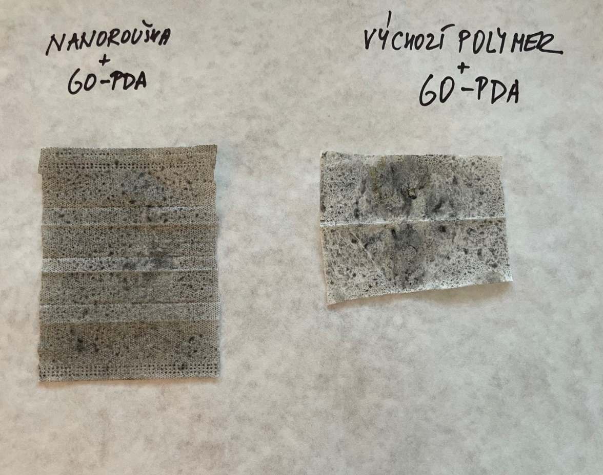

B
A
Figure 1: Figure 1: GO-PDA injection on nanohole (A), starting polymer PP-PVDF-PP with GO-PDA injection

In our experiments, we have demonstrated the fungicidal ability of GO by long-term testing of pine chips with dimensions of approximately 50x25x10 mm infested with the domestic woodworm (Serpula lacrymans), in accordance with the standard ČSN EN 113 for the determination of wood resistance to woodworm. The aqueous suspension of GO was applied in a single layer to the pine squares using a mechanical sprayer (see Figure 2). After the tests were completed, the samples were washed and dried to a constant weight with a weight loss of 0.62-0.76% (Roupcova, 2018).
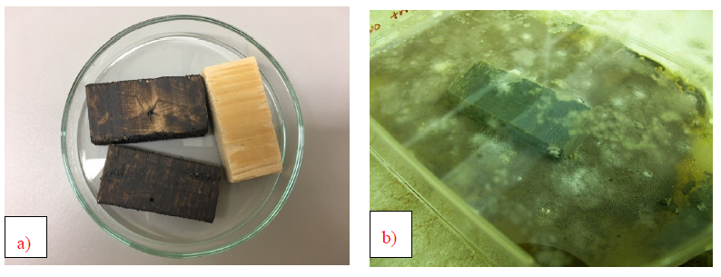Figure 2: Prepared samples for impregnation of GO for the wood borer test - sample preparation a) before the end of the tests b)
  - Conclusions

GO is obtained by oxidation with strong oxidising agents and is a precursor for the production of graphene. It has unique properties, e.g., electronic, magnetic, optical, thermal, it is also an electrical insulator, among other things it is hygroscopic and dispersible. According to the physical phenomena and measurable quantities of the materials used for sensor preparation, sensors are divided into optical, electrochemical, piezoelectric, magnetic, thermal, etc. GO appears to be an effective material for combating Covid-19 and other biological agents and is a basic material for the preparation of biosensors for virus diagnostics (Srivastava et al., 2020). Last but not least, it is a suitable carrier for the immobilisation of enzyme biocatalysts. Pilot experiments will be further developed to demonstrate its ability to capture viruses or bacteria.

ACKNOWLEDGEMENTS
The publication was written within the project of Norway grants “Innovative carbon-based sorbents as an efficient way of wastewater treatment” project number 3213200008.
References
Chen J., Peng H., Wang X., Shao F., Yuan Z., Han H., 2014, Graphene oxide exhibits broad-spectrum antimicrobial activity against bacterial phytopathogens and fungal conidia by intertwining and membrane perturbation, Nanoscale, 6(3), 1879-89.
Chen, L., Song, L., Zhang, Y., Wang, P., Xiao, Z., Guo, Y., Cao, F., 2016, Nitrogen and Sulfur Codoped Reduced Graphene Oxide as a General Platform for Rapid and Sensitive Fluorescent Detection of Biological Species. ACS Appl. Mater. Interfaces, 8 (18), 11255–11261.
Chen, Y.-N., Hsueh, Y.-H., Hsieh, C.-T., Tzou, D.-Y., Chang, P.-L., 2016, Antiviral Activity of Graphene–Silver Nanocomposites against Non-Enveloped and Enveloped Viruses. International Journal of Environmental Research and Public Health, 13 (4), 430.
Chung Ch., Kim Y.K., Shin D., Ryoo S.R., Hong B.H., Min D.H.,2013,Biomedical Applications of Graphene and Graphene Oxide, Accounts of Chemical Research, 46(10), 2211–2224.
Chung, H.-C., Nguyen, V. G., Kim, C. U., Do, H.-Q., Park, B. K., Park, Y. H., Song, D.-S., Kong, A., Ryu, J.-C., Kang, K.-S., 2021, Application of Nano-Graphene Oxide as Nontoxic Disinfectant against Alpha and Betacoronaviruses. Veterinary Medicine and Science, 7 (6), 2434–2439.
Fan, Z., Yust, B., Nellore, B. P. V., Sinha, S. S., Kanchanapally, R., Crouch, R. A., Pramanik, A., Chavva, S. R. Sardar, D., Ray, P. C., 2014, Accurate Identification and Selective Removal of Rotavirus Using a Plasmonic–Magnetic 3D Graphene Oxide Architecture. J. Phys. Chem. Lett., 5 (18), 3216–3221.
Fernández-Merino M.J.,Guardia L.,Paredes J.I.,Villar-Rodil S., Solís-Fernández P., Martínez-Alonso A., Tascón J.M.D., 2010, Vitamin C Is an Ideal Substitute for Hydrazine in the Reduction of Graphene Oxide Suspensions, The Journal of Physical Chemistry C, 114(14), 6426–6432.
Ghulam A.N., Santos O.A.L., Hazeem L., Backx B.P., Bououdina M., Bellucci S., 2022, Graphene Oxide (GO) Materials-Applications and Toxicity on Living Organisms and Environment, J Funct Biomater,13(2),77.
Hermanova S., Zarevucka M., Bousa D., Mikulics M., Sofer Z., 2016, Lipase enzymes on graphene oxide support for high-efficiency biocatalysis, Applied Materials Today, 5, 200-208.
Hermanova S., Zarevucka M., Bousa D., Mikulics M., Sofer Z., 2015, Grephene oxide immobilzed enzymes show high thermal and solvent stability, Nanoscale, 7, 5852–5858.
Kasbe P. S., Gade H., Liu S., Chase G. G., Xu W, 2021, Ultrathin Polydopamine-Graphene Oxide Hybrid Coatings on Polymer Filters with Improved Filtration Performance and Functionalities, ACS Appl. Bio Mater, 4 (6), 5180–5188.
Kinnamon, D. S., Krishnan, S., Brosler, S., Sun, E., Prasad, S., 2018, Screen Printed Graphene Oxide Textile Biosensor for Applications in Inexpensive and Wearable Point-of-Exposure Detection of Influenza for At-Risk Populations. J. Electrochem. Soc., 165 (8), B3084.
Klouda, K., Roupcova, P., Kubatova, H., Filip, B., Krsek, D., Batrlova, K., 2022, Modification of graphene oxide surface by dopamine hydrochloride, NANOCON Conference Proceedings – International Conference of Nanomaterials, 161-167.
Kuba, M., 2022, Graphene oxide reduction with a focus on ‘’Green reduction’’, Bachelor Thesis, VSB-Technical university of Ostrava, Ostrava, CZ.
Li, S., Gu, Y., Lyu, Y., Jiang, Y., Liu, P.,2017, Integrated Graphene Oxide Purification-Lateral Flow Test Strips (IGOP-LFTS) for Direct Detection of PCR Products with Enhanced Sensitivity and Specificity. Anal. Chem., 89 (22), 12137–12144.
Maio, F. D., Palmieri, V., Babini, G., Augello, A., Palucci, I., Perini, G., Salustri, A., Spilman, P., Spirito, M. D., Sanguinetti, M., Delogu, G., Rizzi, L. G., Cesareo, G., Soon-Shiong, P., Sali, M., Papi, M., 2021, Graphene Nanoplatelet and Graphene Oxide Functionalization of Face Mask Materials Inhibits Infectivity of Trapped SARS-CoV-2. iScience, 24 (7).
Mangadlao J.D., Santos C.M., Felipe M.J.L., de Leon A.C., Rodrigues D.F., Advincula R.C., 2015, On the antibacterial mechanism of graphene oxide (GO) Langmuir-Blodgett films, Chemical Communications, 51(14), 2886-9.
Nehra, A., Chen, W., Dimitrov, D. S., Puri, A., Singh, K. P., 2017, Graphene Oxide-Polycarbonate Track-Etched Nanosieve Platform for Sensitive Detection of Human Immunodeficiency Virus Envelope Glycoprotein. ACS Appl. Mater. Interfaces, 9 (38), 32621–32634.
Omran B., Baek H-K., 2022, Graphene-derived antibacterial nanocomposites for water disinfection: Current and future perspectives, Environ. Poll, 298, 118836.
Rhazouani, A., Gamrani, H., El Achaby, M., Aziz, K., Gebrati, L., Uddin, Md Sahab, Aziz, F., 2021, Synthesis and Toxicity of Graphene Oxide Nanoparticles: A Literate review of In Vitro and In Vivo Studies, Environmental Mutagenicity and Carcinogenicity of Nanomaterials.
Roupcova, P., 2018, Monitoring of the ecotoxicity of carbon based nanoparticles, PhD Thesis, VSB-Technical university of Ostrava, Ostrava, CZ.
Roupcova, P., Klouda, K., Kubatova, H., Slivkova, S., 2021, Preparation and modification of hybrid compounds based on GO-biochar and verification of their sorption properties, Chemical Engineering Transactions, 84, 61-66.
Sametband M., Kalt I. Gedanken, A., Sarid R., 2014, Herpes Simplex Virus Type-1 Attachment Inhibition by Functionalized Graphene Oxide. ACS Appl. Mater. Interfaces, 6 (2), 1228–1235.
Song, J.-X., Tang, X.-Y., Zhou, D.-M., Zhang, W., James, T. D., He, X.-P., Tian, H., 2017, A Fluorogenic 2D Glycosheet for the Simultaneous Identification of Human- and Avian-Receptor Specificity in Influenza Viruses. Mater. Horiz., 4 (3), 431–436.
Srivastava A.K., Dwivedi N., Dhand C., Khan R., Sathish N., Gupta M.K., Kumar R., Kumar S., 2020, Potential of graphene-based materials to combat COVID-19: properties, perspectives, and prospects, Mater Today Chem.,18:100385.
Xu Z., Sun H., Zhao X., Gao Ch.,2013, Ultrastrong Fibers Assembled from Giant Graphene Oxide Sheets. Advanced Materials, 25(2), 188–193.
Yang, H., Li, J., Zhai, L., Yu, H., 2014, Simple synthesis of graphene oxide using ultrasonic cleaner from expanded graphite, Industrial & Engineering Chemistry Research, 53(46), 17878-17883.
Ye, S., Shao, K., Li, Z., Guo, N., Zuo, Y., Li, Q., Lu, Z., Chen, L., He, Q., Han, H., 2015, Antiviral Activity of Graphene Oxide: How Sharp Edged Structure and Charge Matter, ACS Appl. Mater. Interfaces, 7 (38), 21571–21579.
Zhang Y., Ren L., Wang S., Marathe A., Chaudhuri J., Li G., 2011, Functionalization of graphene sheets through fullerene attachment, Journal of Materials Chemistry, 21(14), 5386–5391.
Zhao, J., Deng, B., Lv, M., Li, J., Zhang, Y., Jiang, H., Peng, C., Li, J., Shi, J., Huang, Q., Fan, C., 2013, Graphene Oxide-Based Antibacterial Cotton Fabrics. Advanced Healthcare Materials, 2 (9), 1259–1266.
Zdarta J., Meyer A.S., Jesionowski T., Pinelo M.A., 2018, General Overview of Support Materials for Enzyme Immobilization: Characteristics, Properties, Practical Utility, Catalysts, 8, 92.

